# Terminology

| Admin | A user of the client’s access (casino), login, password (Unique within the platform) |
| --- | --- |
| Game parameters | Data needed for correct launch and operation of the casino games (for example denomination, coin value, currency, language, RTP config) |
| Group of Banks (Agent) | A Group of Banks (Agent is an alternative name) is a form of accounting within a platform regarding a specific casino. The platform also allows you to set up the games individually for every group of banks. (For example, 1 group of banks = 1 currency)  Players are unique and strictly tied to the same group of banks. If you need to give the player an opportunity to play in several groups of banks, you have to create copies of the player in every group of banks. |
| Player’s game actions | Player's bets in any game of the platform |
| Player’s non-game actions | Deposit, withdrawal of funds from the player’s balance within the platform from without in case of wallet integration. (In case of seamless integration the account is taken on the part of the external web-site. |
| Player | The final user of the system. He is unique within the casino system and is tied to his group of banks. |
| Spin | Single player’s game action. Terminology is taken from the main part of the casino slot games. |
| The screen layout of the slot-machine | Symbols (arrangement of the symbols) on the screen of the slot machine when the reels are sloped after the spin. |
| Playing state of the game | The current state (feature) of the game is applied to the slot-machines. The rule is to distinguish the following playing states: standard (base), free (freegame, respin feature), bonus (bonus feature), double (double feature) |
| Provider, games section, brand | Grouping of the total game set according to the original brand. |
| Back office, admin panel | The administrative interface of the platform |
| Default settings | The term means that the settings will be automatically applied to a new group of banks (as a rule, we are talking about the settings of the game, the jackpot game settings) |
| Limit of the game’s bank | The special mode of control of the game’s return where each potential gain compares to the current financial state of the game. |
| Limit of the maxwin | The special mode which limits the win by the set value |
| RTP | RTP - Return to player |
| string id | The main identifying object of the platform. |
| Player’s id | There are several identifying objects of the player - id:   * player’s name (player) - player’s username * internal identifying object. It’s the main on the platform’s part. * external identifying object. It coincides with the identifying object of the web-site |
| session | a session of the interaction of one player of one group of banks of one casino with one game launched with one set of launch parameters, which stores information about each game and non-game action (the second is optional, relevant only in the presence of this action specifically in the game) |
| Game limitation modes | A special game mode which limits return set by the developer. The platform provides 2 modes: bank and maxwin (see page 13). |
| Delta | Difference |

# Home

General information about admin access: General Data, Data Integration.

<http://joxi.ru/L218Y4vCRknnqm>

also here you can change your password

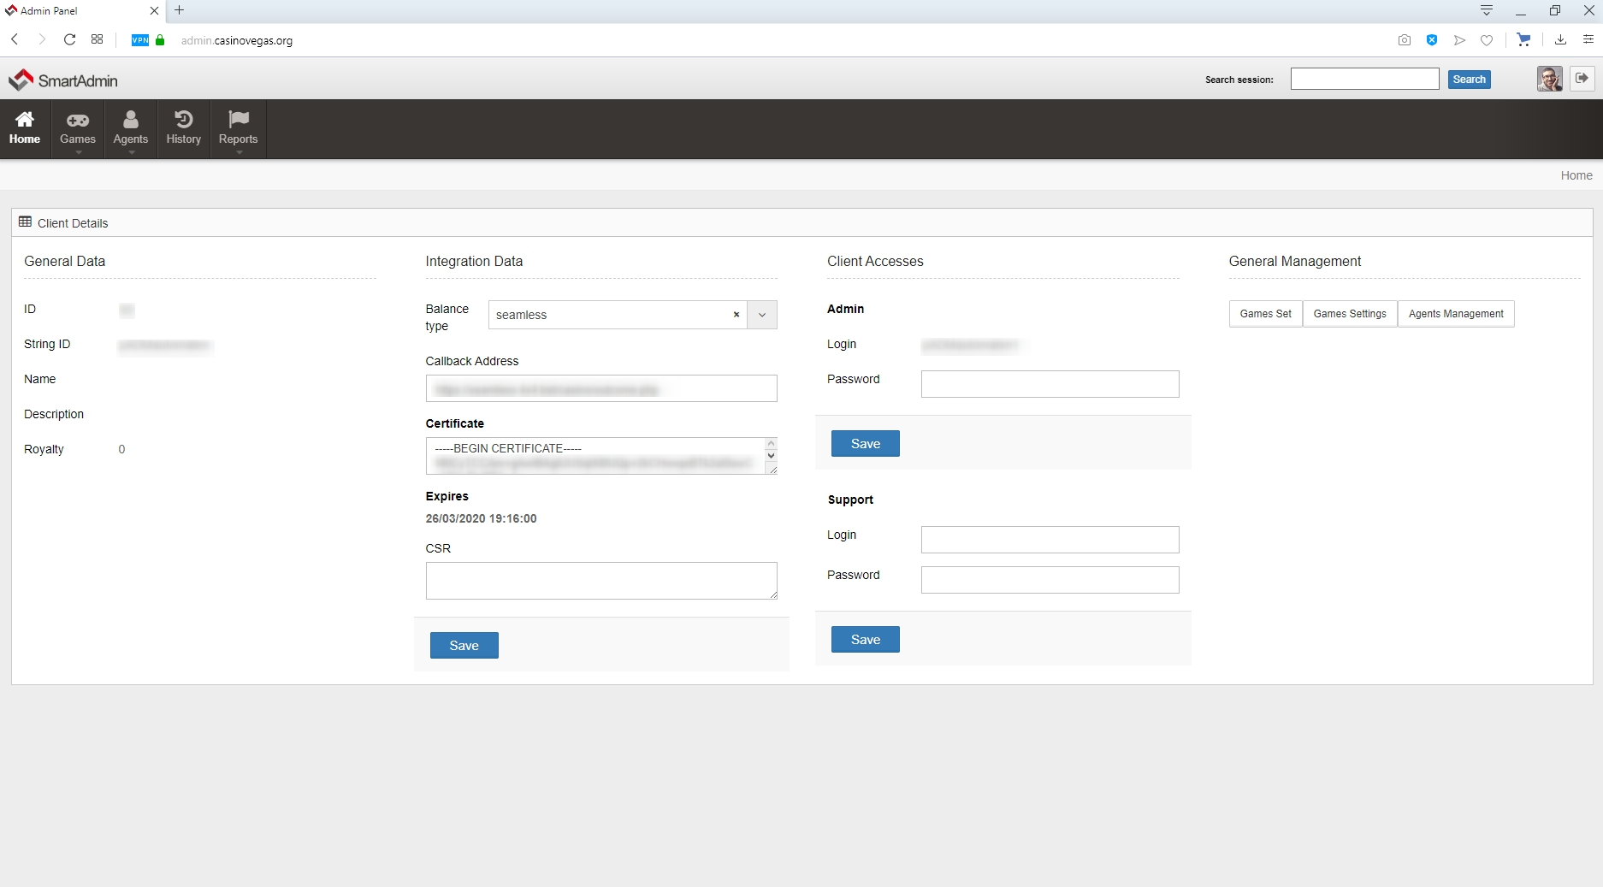

# Games

## **Games Set.**

Full set of existing games.

<http://joxi.ru/1A5g6vyFD8vEvm>

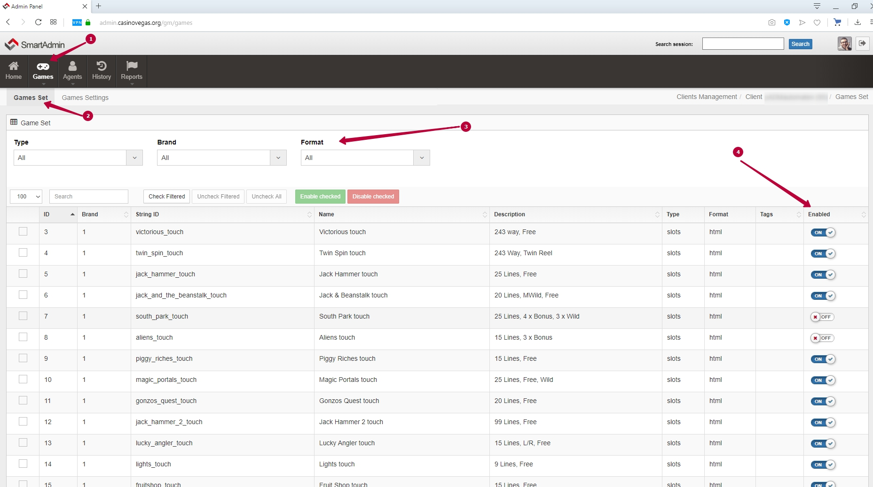

**explanation of the numbers from the screenshot:**

1. games tab
2. games tab: a game set
3. filters to search for games type, brand, format
4. on/off turning games on and off

## Games settings.

patches are multi-level templates for configuring games.

there are 4 levels of patches

1) default — system patch, unchangeable

2) currency — by default, the patch is configured for a specific currency, which you can change at will so that all Bank groups in this currency are automatically configured depending on your wishes. but it is better to use an alternative patch for customization for your convenience and clarity.

3) alternative — recommended patch, you can present this patch as a template for your agent's settings, depending on your requests. when you apply this template to Bank groups they automatically accept your own unique alternative patch settings instead of the default currency settings.

4) Agency — if you imagine patches as a pyramid, this is the highest level of settings that overlaps all the previous ones. it allows you to configure each game directly for each agent (Bank group) individually.

## 

### Default patches.

this is a page with technical information nothing can be changed here <http://joxi.ru/MAjNXZGTjNEGLA>

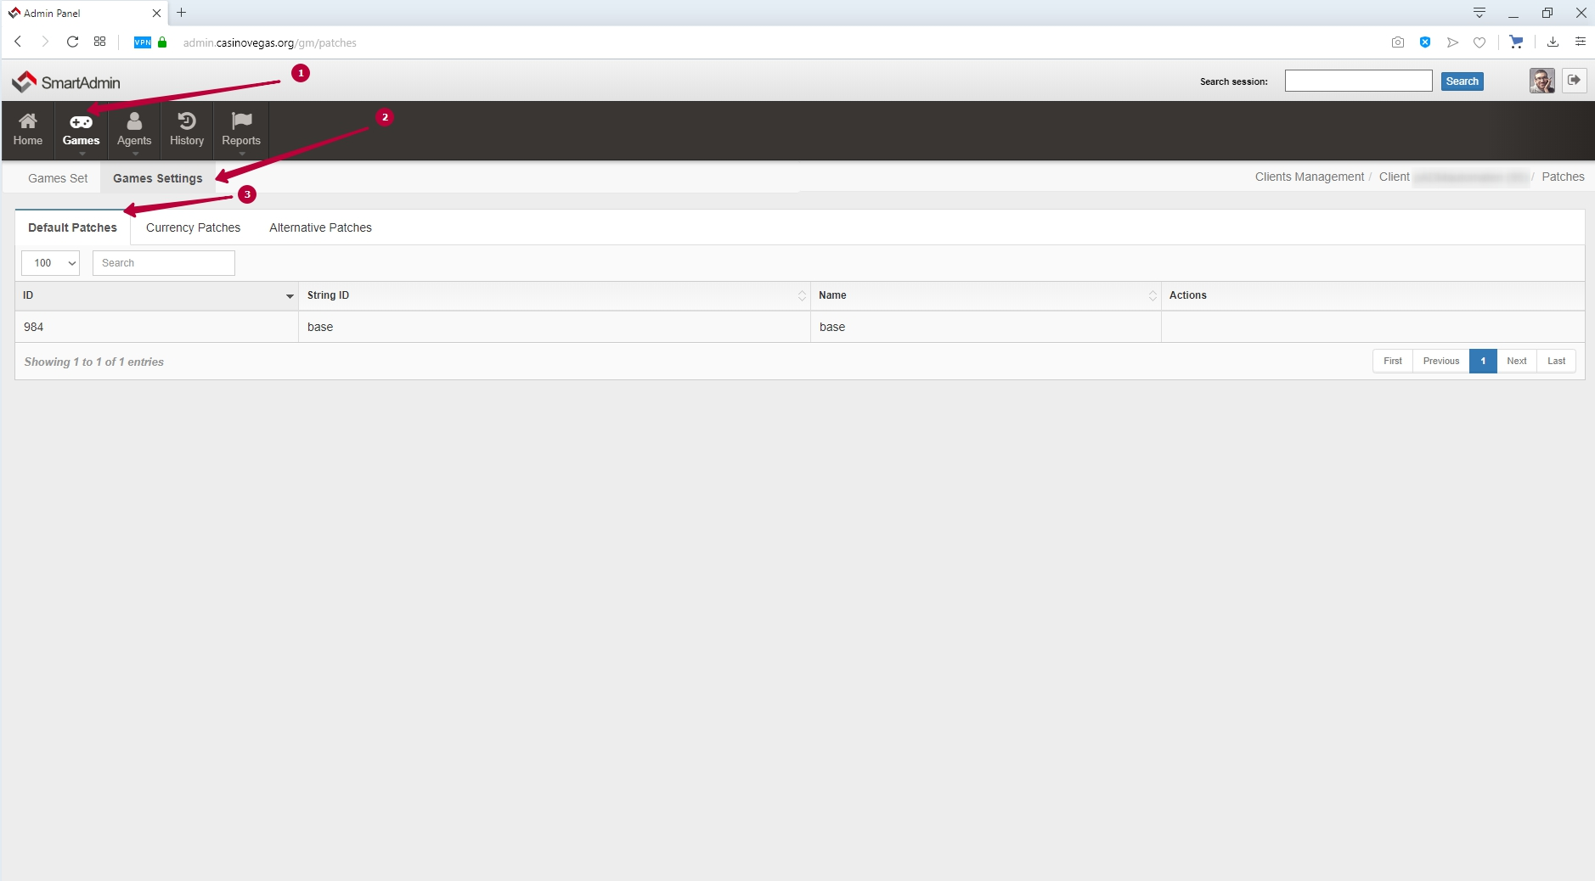

### Currency patches.

Here you can see what the patch settings for each existing currency look like. we do not recommend changing these patches, but for your convenience, we suggest that you work directly with the following patch type - an alternative patch.

<http://joxi.ru/V2VlVEaidlMzPr>

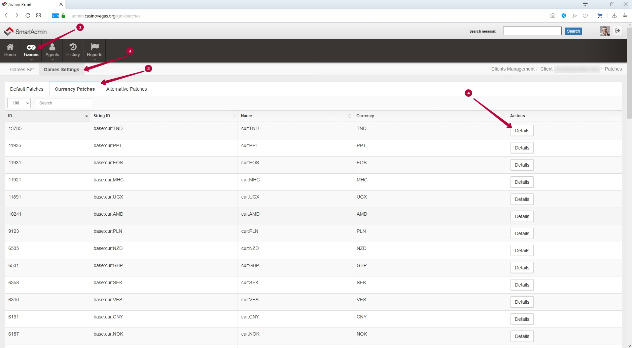

When you click on the number 4 from the previous screenshot on the "details" button, you go to the patch editing menu. but we will pass to the consideration of mass settings of games and to changing patch settings later.

<http://joxi.ru/52aOdE8HEwBy8r>

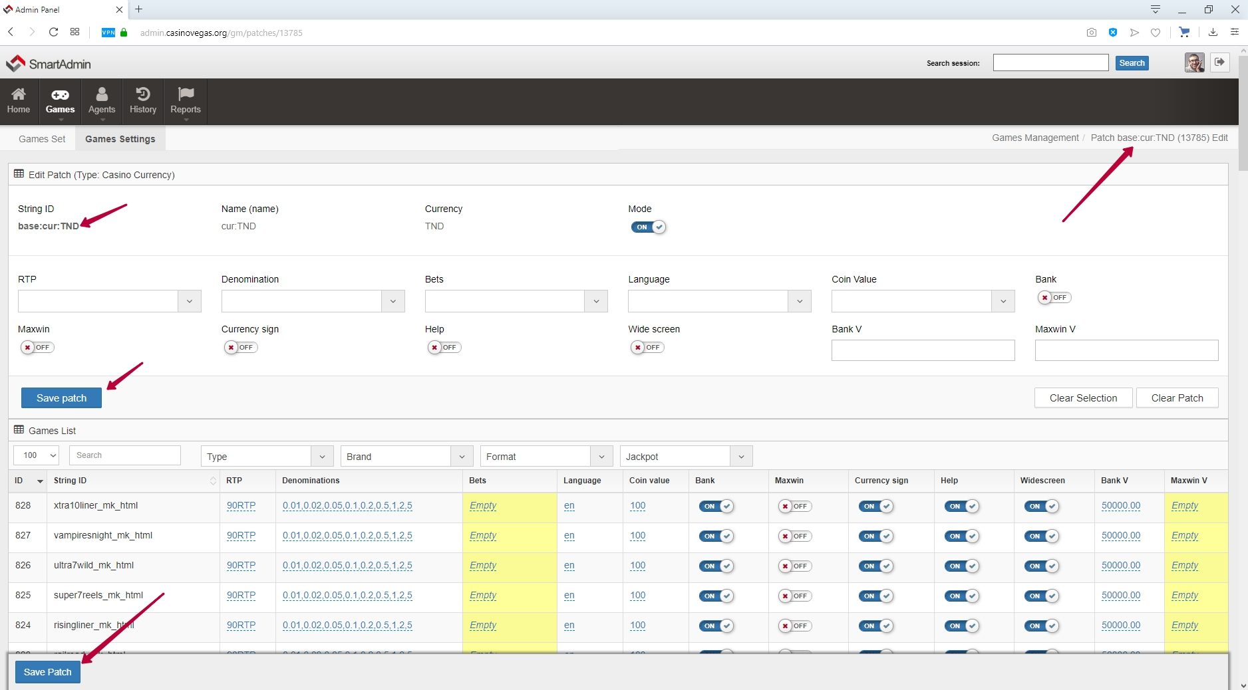

### Alternative patches.

Create new patches to configure agents (Bank groups).

<http://joxi.ru/xAeka6JhR47qjm>

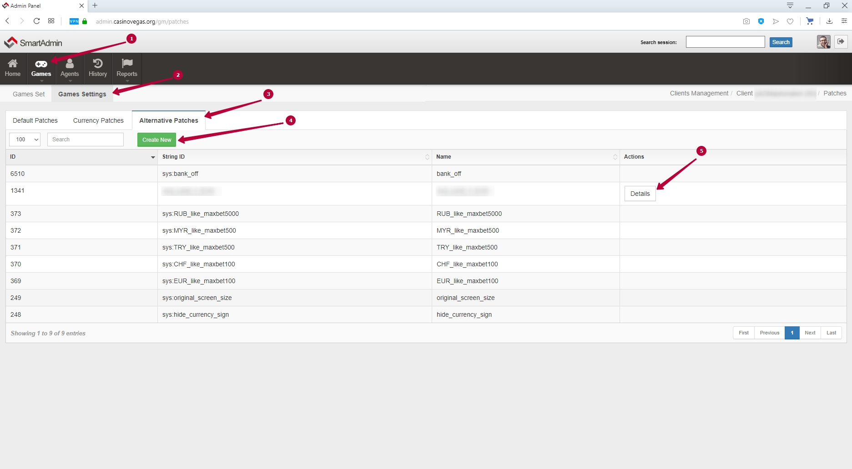

To create a new settings template, you have click on the green button "create new" under item 4 in the screenshot.

To configure existing one's alternative patches you have to click on the button "details" under item 5 in the screenshot.

So, the patch settings tab. it looks identical to the agent's individual settings tab. therefore, it is important to note that each agent and each agent game can be configured individually to your liking.

<http://joxi.ru/52aOdE8HEyNzDr>

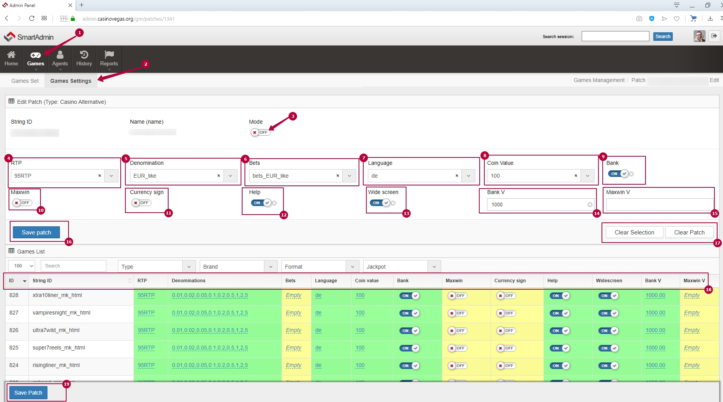

**explanation of the numbers from the screenshot:**

1. Mode - visible or not visible for use in the next "agents" tab
2. RTP - it's short for Return to Player, which translates to "payout percentage". This value indicates a theoretical refund based on the bets placed by the player for a certain number of rounds. you can choose one of the three options.

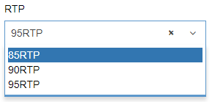

1. Denomination - typical bet line settings for currencies (the most common)

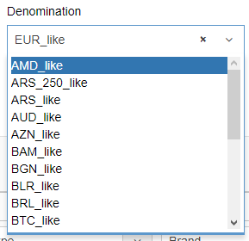

1. Bets - the level of bets. it means "bet level", for example as for the provider NetEnt, which is displayed in the left corner of the screen. This is also used as a multiplier in games from Wazdan and EGT.

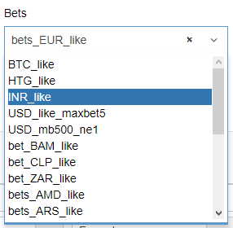

1. Language - language directly in the game, which will be written rules and words on the buttons in the slot machine

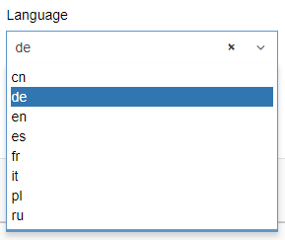

1. Coin Value - coin multiplier for Gaminator and Igrosoft (remnants of the old) choose 100 please for correct work.
2. Bank on/off - enable or disable restriction of games by banks (see page 13)
3. MaxWin - (see page 13)
4. Currency sign - the conditional image of the currency icon inside the game ($, ₽, €)
5. Help in games on/off
6. Widescreen - there is a filling with a game of all free screen space. in order not to lose the original proportions - it is better to use "off" to that the game doesn't stretch out ugly and unnatural if the screen is too wide.
7. Bank V (Value) - the value of the Bank game (see page 13)
8. Maxwin V (Value) - the multiplier maximum win on the bet of the player
9. Save patch
10. Clear Selection & Clear Patch
11. the table header duplicates in the columns the symbols from the patch settings interface. as I said before, each game for patch or agent can be customized individually. for example, for a very popular game put a lower value Bank game or RTP
12. Save patch - duplicated as from the previous item 16

**\*for a detailed description of the logic, The value of the game Bank and the maximum amount of winnings** see page 13

# Agents

## Agents.

here you can see all your agents (Bank groups), create new or edit:

<http://joxi.ru/a2X6PExiwjM6Nr>

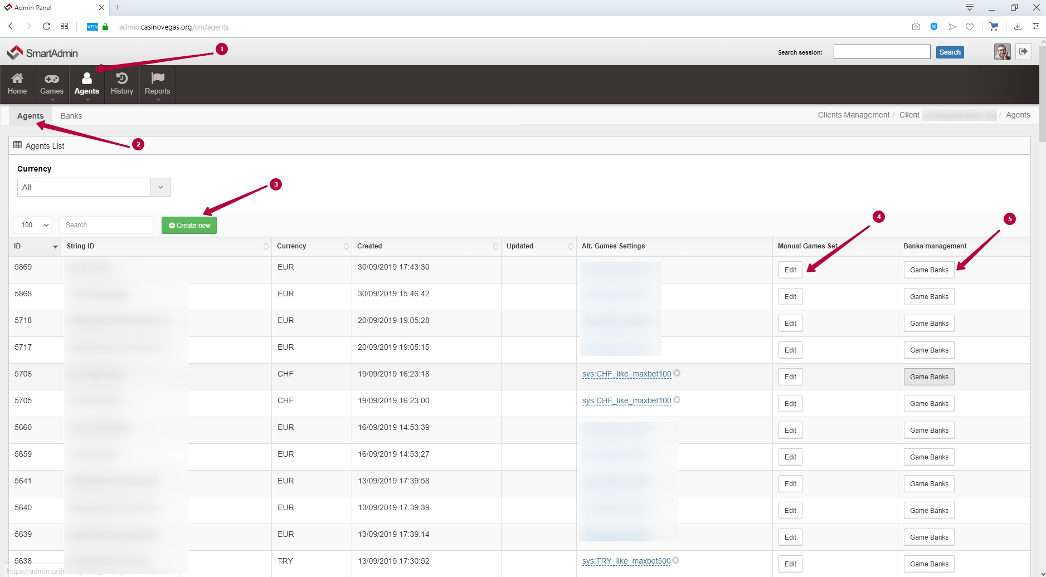

**explanation of the numbers from the screenshot:**

1. The Agents tab
2. Agents: Agents
3. Create new Agent (bank group)
4. in the screenshot above item 4 leads to editing the settings of the individual agent (agency patches).

<http://joxi.ru/GrqENxzC4BVaqr>

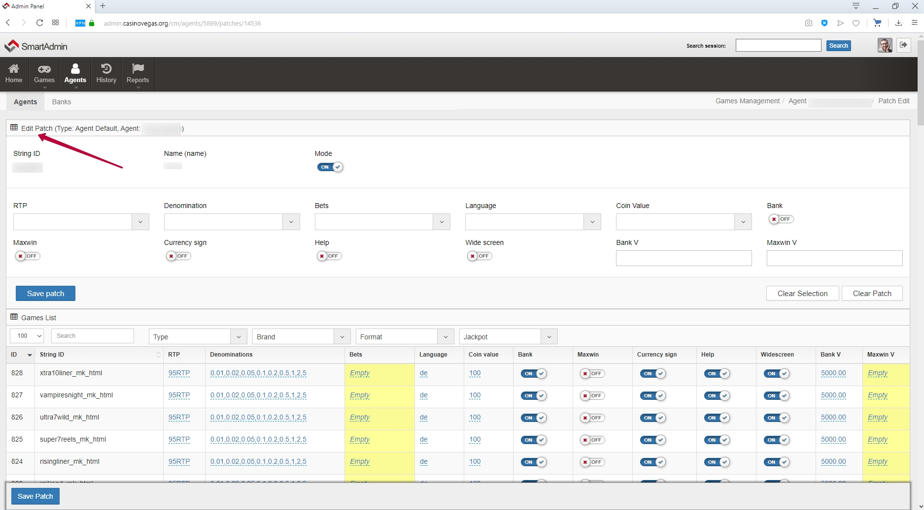

5) on the screenshot item 5 leads to the display of the value of the banks of the individual agent

<http://joxi.ru/J2bnLY9C0nBQ32>

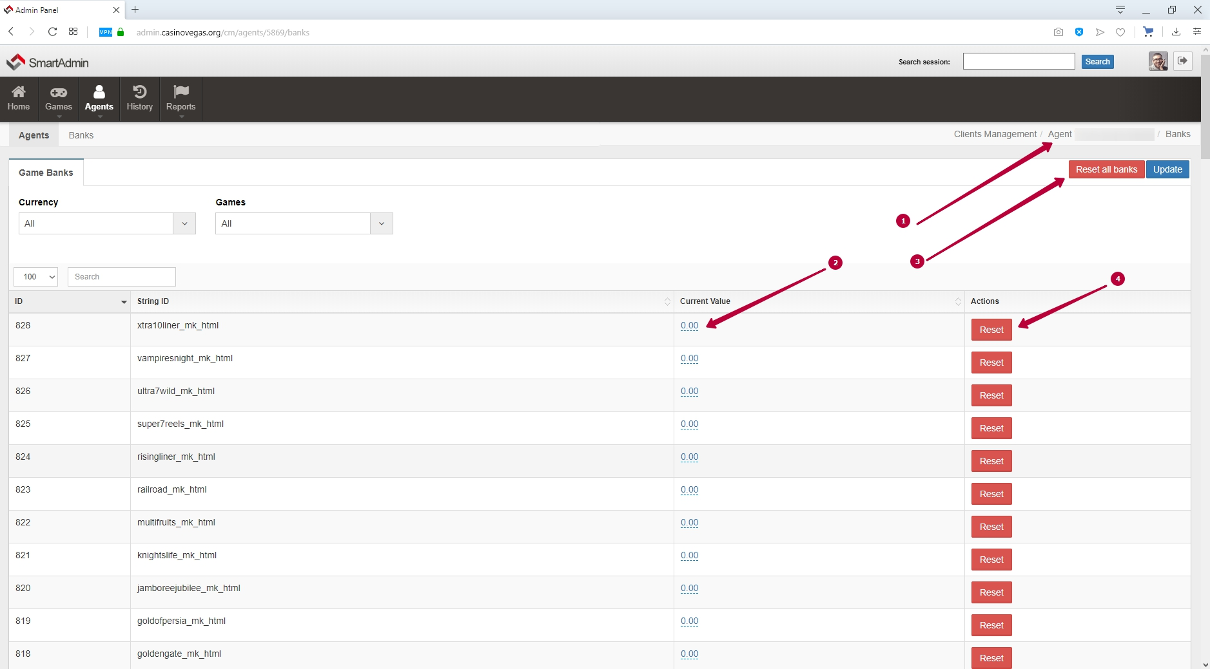

**explanation of the numbers from the screenshot:**

1. name of the agent to be edited.
2. current value should not be equal to 0 but should be equal to the assigned value of the Bank, for the correct operation of the game on a given RTP and payout.
3. reset banks of all games.
4. reset Bank individual game.

banks in the game depending on the number of bets players reset periodically from once a week to daily.

## 

## Banks.

Through the menu "agents: banks" it will be easier to get to the reset of banks.

<http://joxi.ru/V2VlVEaidlMgxr>

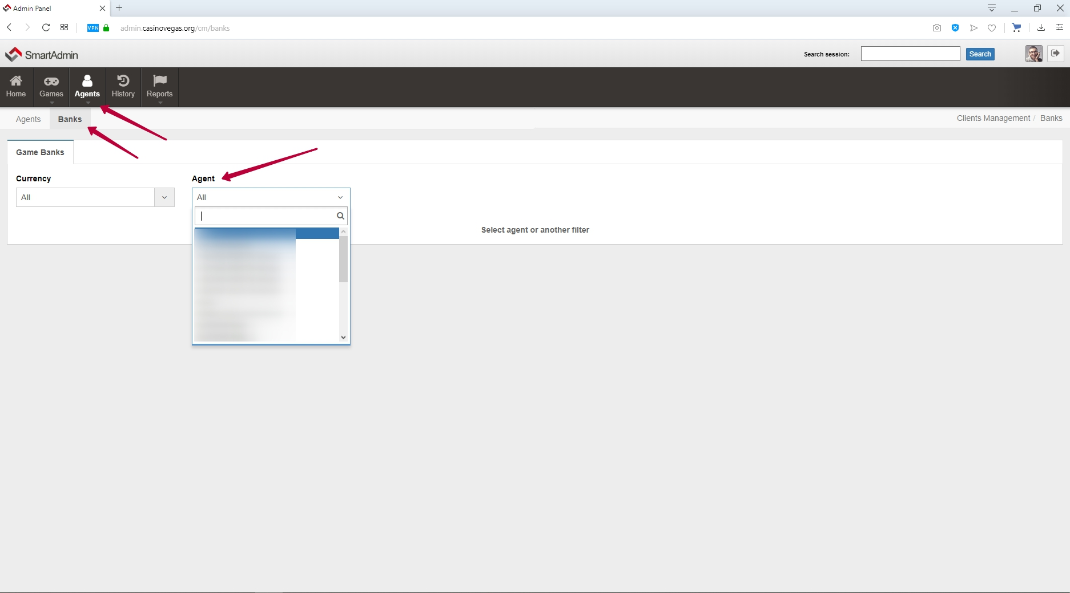

Select the agent in the filter and the Bank reset menu Opens for each agent..

<http://joxi.ru/Vm6MWlvu4N1gNr>

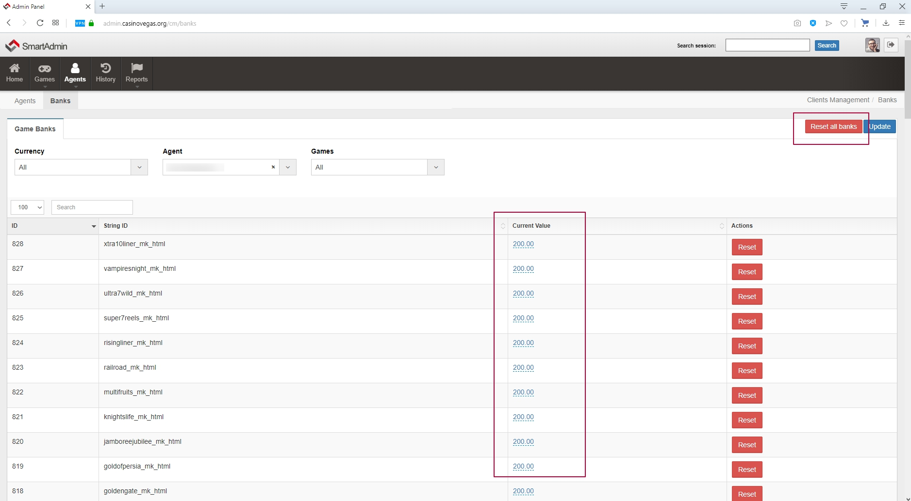

# History

Here you will see all sessions of your players for a certain period of time.

<http://joxi.ru/1A5g6vyFD8v9Vm>

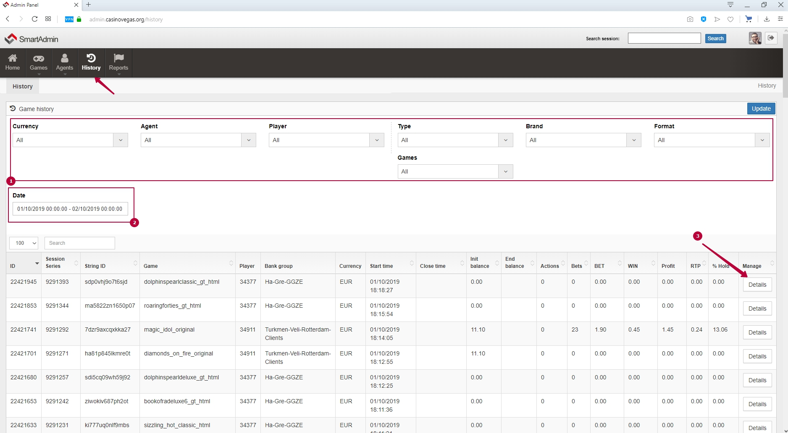

**explanation of the numbers from the screenshot:**

1. filters to search for sessions
2. specifying a specific time period
3. details of the game session: <http://joxi.ru/Dr8lLjvioqdZpr>

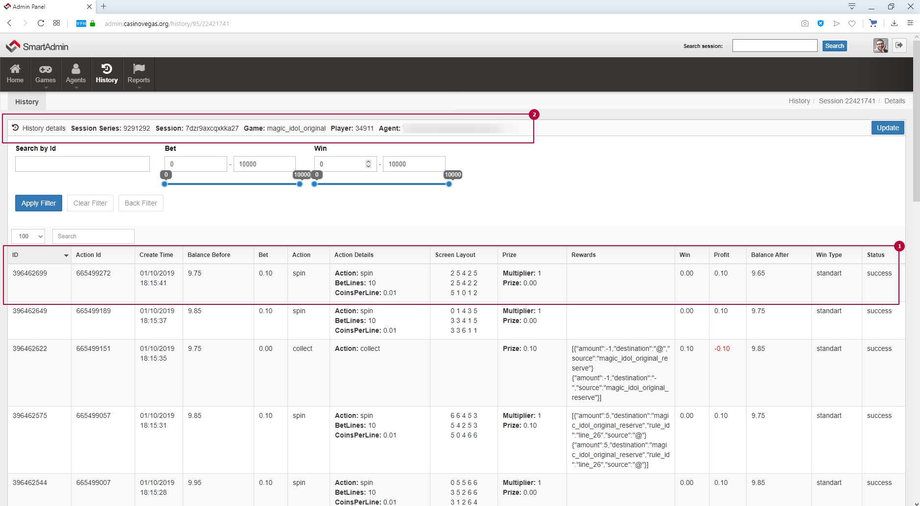

**explanation of the numbers from the screenshot:**

1. information about spin
2. description of the game session

# Reports

## Agents

Financial report on agents.

<http://joxi.ru/gmvdGz3Hqjwy6A>

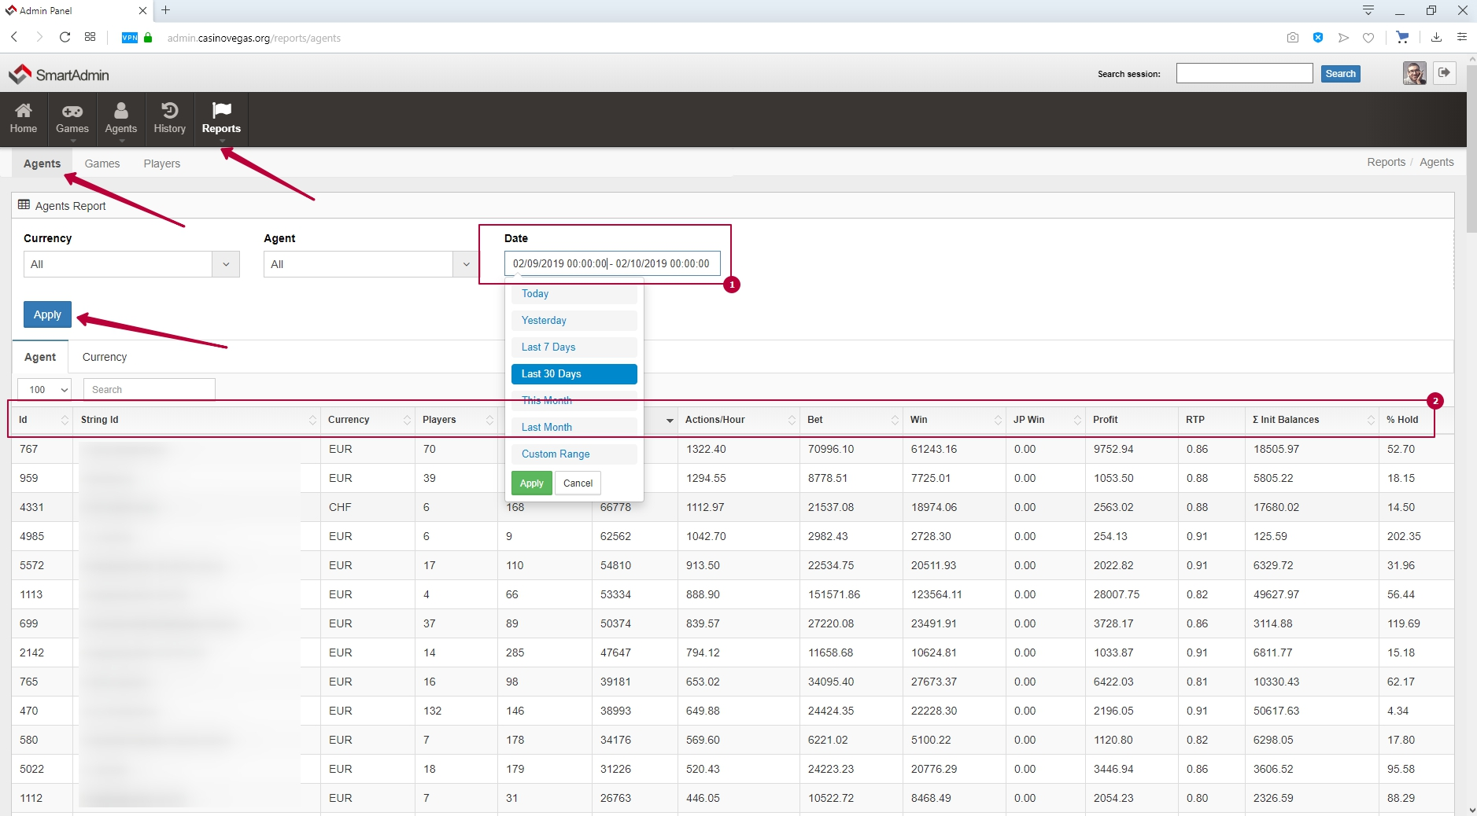

**explanation of the numbers from the screenshot:**

1. specifying a specific time period
2. information about the final performance of each agent

## Games

Financial report on games.

<http://joxi.ru/DmBakqnTJKvwzr>

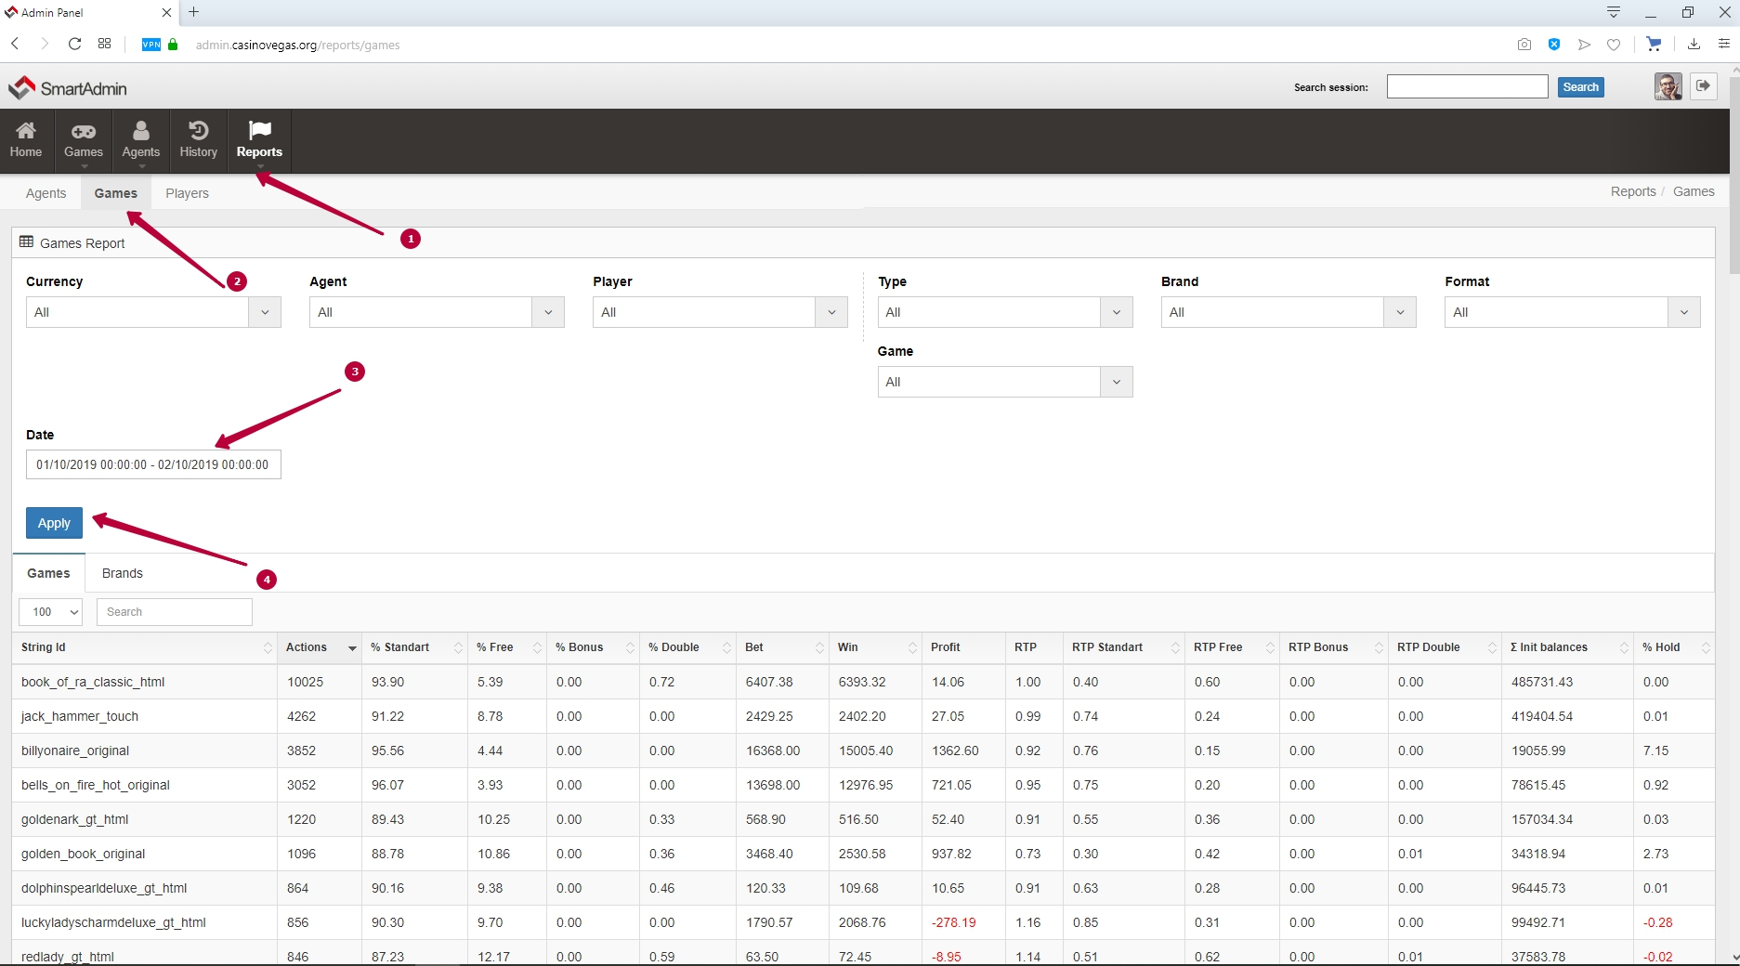

## 

## Players

Financial report on players.

<http://joxi.ru/KAxKENVSZ9pMj2>

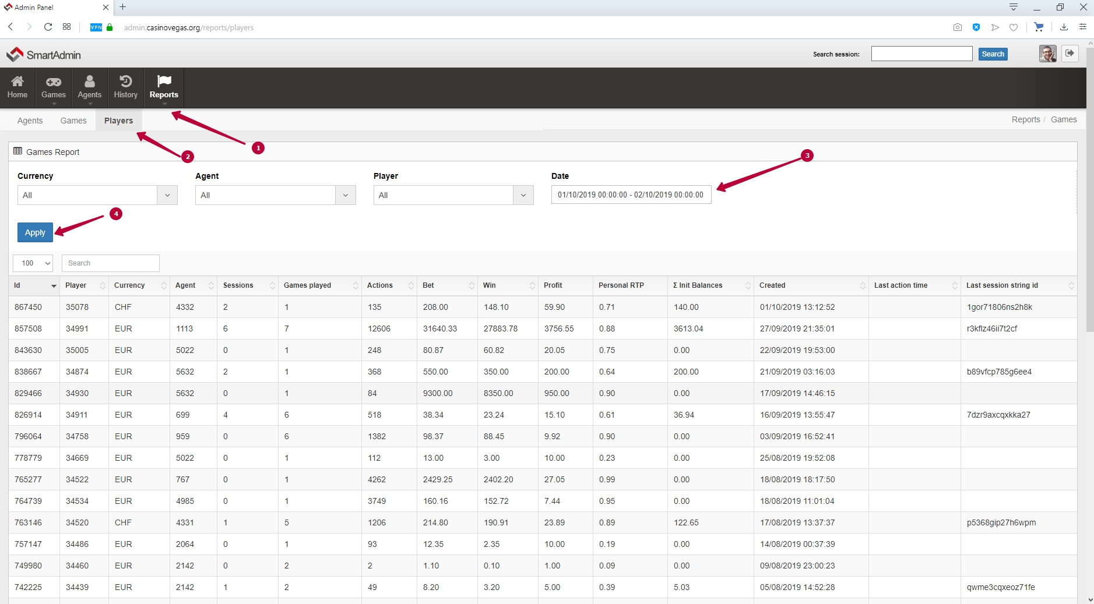

# Game Bank Value and Max Win

**Game Bank Value** - a special game return control mode in which each potential win is compared with the current financial condition of each game

**MaxWin** - a special control mode of the game return, in which each win is limited to a specified value of the maximum win per spin  
  
Set the MaxWin value for the corresponding operating mode. The value must be expressed in monetary terms. (Example: MaxWin = 125.00 means that the Maximum win for one combination will not exceed 125.00 in the currency of your casino, the main group of banks). If you do not use MaxWin mode, leave this value unchanged (any).

**Game’s bank limit and max win limit.**

This mode can be used for:  
- limit the win above the specified value per line (in case of MaxWin)

- limit the total amount of wins by start game bank value plus the current amount of money (in case of Game Bank limit)

These parameters influence the game’s RTP (return-to-player) in the game, reduce it. RTP reduce is not calculated explicitly, but usually, we are talking about:

* 5-10% RTP reduce using a game bank with start values within the game’s average win values (one-time payment for 3-4 older combinations). It’s important that the indicated numerals are approximate and may vary by volatility in different games.
* 5-15% RTP reduce using MaxWin. MaxWin limit cuts off the largest payouts in the game. It’s important that the indicated numerals are approximate and may vary by volatility in different games.

**Principle of operation:**

| bank | Each game has a bank that accumulates means from every bet and reduced by wins. A game’s bank value is an internal parameter of the system.  In the case of using the game’s bank limit, its value is used to identify if it is possible to pay the win by each spin.   - total game’s bank value is less than the amount of payment=the payment can not be made=respin (the process is hidden from the player) It is important that we are talking about the next random spin, not a false non-winning combination. -total game’s bank value is more than the payment = payment to the player. In exceptional cases, the game’s bank value can be negative. In that case, the game will be “greedy” (it doesn’t let the player wins) up to the positive balance (game’s bank value can be updated by the administrator) |
| --- | --- |
| maxwin | MaxWin parameter limits the maximum win in every spin by its value (is indicated monetary) |
| bank + maxwin | Combination of two parameters where maxwin and bank check take place. This mode can greatly affect the gameplay if settings are made incorrectly. |

**General advice on setting up the default parameters in case of their use.**

**Please note** that the Administrator the decision

| bank | 1. do not set Default Game Bank Value: = 0  2. you should not set too high a value (from 2000-5000 Euros or the equivalent in another currency), otherwise, the restriction will be almost not noticeable, or will not work at all  3. normal indicators (based on the experience of medium and large customers) in the range from 300 to 1000 Euros, or the equivalent in another currency  4. be guided by the amount that you are ready to lose in each game, in the form of a possible win at the initial stage of the project launch  5. It is recommended to apply this restriction in games where, according to the rules, very large winnings are possible (multipliers from 10,000 times the initial bet and more) |
| --- | --- |
| maxwin | 1. you cannot install = 0, or at least the smallest prize on the line in the game  2. it is not recommended to set less than the average payline in the game (as a rule, most of the returns are formed by the average and above-average games, but this principle may be different for games of different volatility)  3. it makes no sense to set too high a value that exceeds the maximum line win  4. normal values of maxwin (based on the experience of medium and large customers) are slightly less than the largest win on the line, or the next value  5. be guided by the amount that you are ready to lose in each game, in the form of a possible win at the initial stage of the project launch |